# **Setting up machine for asp.net core development**

we will **install the required software and set up our machine for .NET Core development**.  
  
**There are 2 softwares that we need to install for .net core application development.**

* An Editor
* .NET Core SDK (Software Development Kit)

**Download and Install an editor for .NET Core Development**  
  
I have windows operating system, so, I will be using **Visual Studio**as the editor for .NET Core application development. You can use any editor of your choice.

* Visual Studio
* Visual Studio Code
* Sublime
* Vim
* Atom
* Etc.

**Download and install Visual Studio**

* Visual Studio Community Edition is free
* the latest version is Visual Studio 2017 and can be downloaded from <https://visualstudio.microsoft.com/>
* To develop .NET Core applications in Visual Studio 2017, please select .NET Core cross-platform development workload   
  [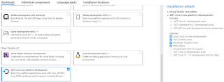](https://4.bp.blogspot.com/-XzaLWj9hH28/XCiKMPpEe-I/AAAAAAAArkY/FrKGv27jMz8MBnSPiSPjYkc_h_e4FSL1ACLcBGAs/s1600/asp.net%2Bcore%2Bsoftware%2Brequirements.png)
* With this selection, .NET Core SDK 2.1 is installed
* You can verify this by creating a new .NET Core Application
* Notice, in the .NET Core Dropdownlist we only have ASP.NET Core 2.1
* As of this recording, the latest stable version of .NET Core is 2.2

**Download and install .NET Core SDK**

* Navigate to <https://dotnet.microsoft.com/download>
* Depending on the operating system you have, download and install the SDK.
* The SDK includes everything you need to build and run .NET core applications.
* The .NET Core Runtime is already included in the SDK. So, if you have installed the SDK, there is no need to install .NET Core Runtime
* The .NET Core Runtime includes just the resources required to run existing .NET Core applications.

After .NET Core SDK 2.2 is installed, create a new .NET Core Application. Notice, in the .NET Core Dropdownlist, we now have ASP.NET Core 2.2 in addition to ASP.NET Core 2.1.   
  
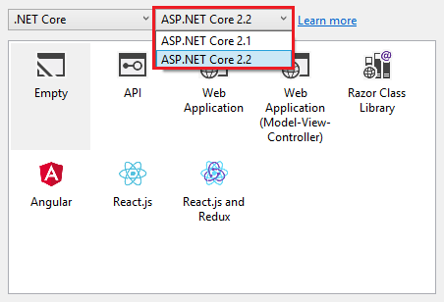   
  
**Next :** Creating a new asp.net core web application using Visual Studio